Experiment 2 : FCFS Scheduling
Code :
#include<stdio.h>
int main() {
int n,awt=0,atat=0,i,j;
printf("FCFS Scheduling Algorithm\nEnter Total Number Of Process : ");
scanf("%d",&n);
printf("Enter Process Burst Time : \n");
int bt[n],wt[n],tu[n];
for(i=0;i<n;i++) {
printf("P[%d] : ",i+1);
scanf("%d",&bt[i]);
}
wt[0]=0;
for(i=1;i<n;i++) {
wt[i]=0;
for(j=0;j<i;j++) {
wt[i]=wt[i]+bt[j];
}
}
printf("\nProcess BT\tWT\tTAT");
for(i=0;i<n;i++) {
tu[i]=bt[i]+wt[i];
awt=awt+wt[i];
atat=atat+tu[i];
printf("\nP[%d]\t%d\t%d\t%d",i+1,bt[i],wt[i],tu[i]);
}
awt=awt/i;
atat=atat/i;
printf("\n\nAverage Waiting Time : %d",awt);
printf("\nAverage Turn Around Time : %d\n",atat);
return 0;
}

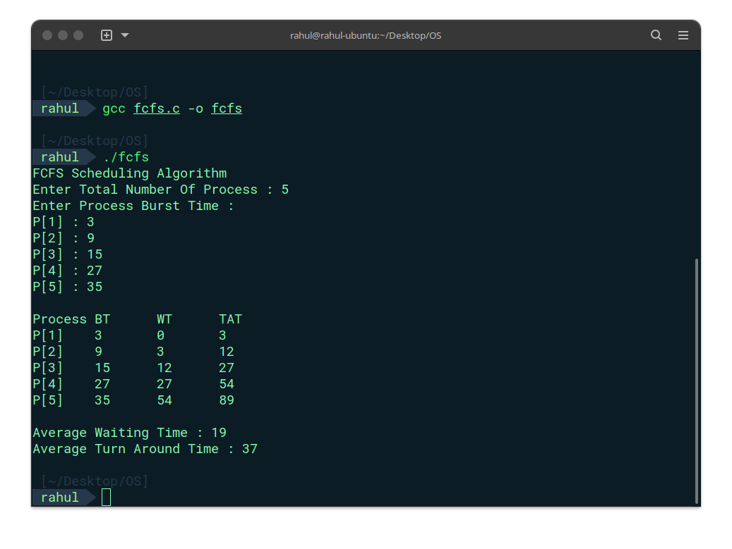
Output :

Experiment 2b: SJF Scheduling
Code :
#include<stdio.h>
struct p {
int process;
int burst;
};
int main() {
int n;
printf("SJF Scheduling Algorithm\nEnter the no of processes:");
scanf("%d",&n);
int wt[n],bt[n],tat[n],ct[n],atat=0,awt=0,temp1=0,temp2=0;
struct p arr[n];
printf("Enter the burst time for the processes:\n");
for(int i=0;i<n;i++) {
printf("P[%d] : ",i+1);
arr[i].process=i+1;
scanf("%d",&bt[i]);
arr[i].burst = bt[i];
}
for(int i=0;i<n-1;i++) {
for(int j=i+1;j<n;j++) {
if(arr[i].burst>arr[j].burst) {
temp1 = arr[i].process;
temp2 = arr[i].burst;
arr[i].process = arr[j].process;
arr[i].burst = arr[j].burst;
arr[j].process = temp1;
arr[j].burst = temp2;
}
}
}
wt[0]=0;
tat[0]=arr[0].burst;
atat = arr[0].burst;
for(int i=1;i<n;i++) {
wt[i] = wt[i-1] + arr[i-1].burst;
tat[i] = tat[i-1] + arr[i].burst;
awt = awt + wt[i];
atat = atat + tat[i];
}
atat=atat/n;
awt=awt/n;
printf("Process\tBT\tWT\tTAT\n");
for(int i=0;i<n;i++) {
printf("P%d\t%d\t%d\t%d\n",arr[i].process,arr[i].burst,wt[i],tat[i]);
}
printf("Average Waiting Time : %d\n",awt);
printf("Average Turn Around Time : %d\n",atat);
return 0;
}

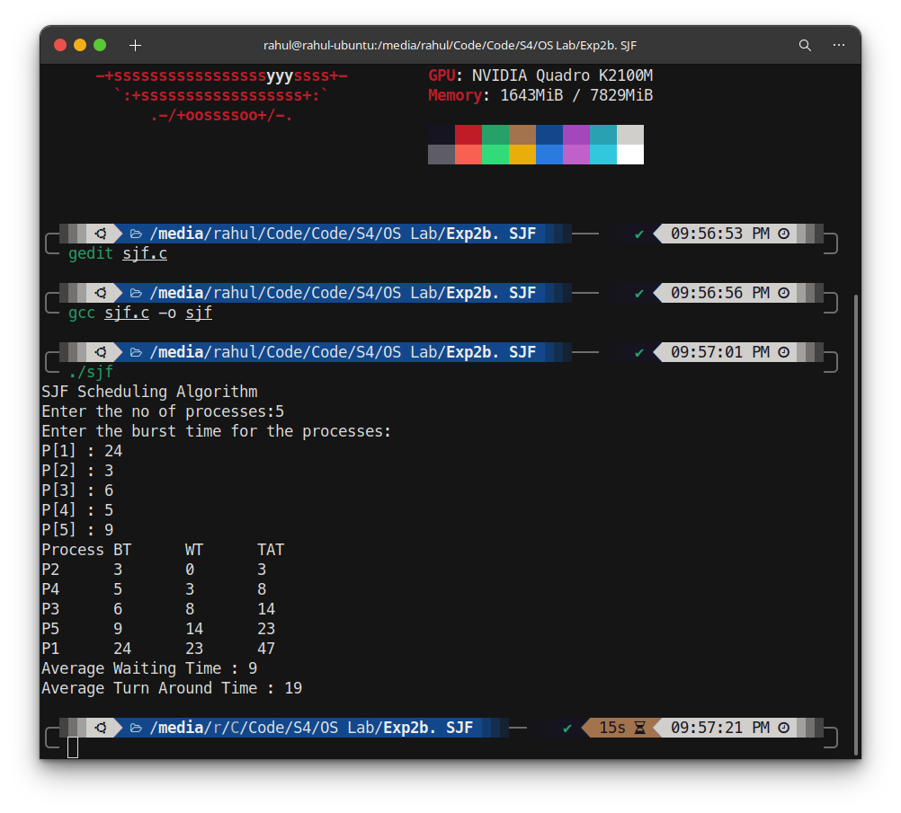
Output :

Experiment 2c: Priority Scheduling
Code :
#include<stdio.h>
struct p {
int process;
int burst;
int priority;
};
int main() {
int n;
printf("Priority Scheduling Algorithm\nEnter the no of processes:");
scanf("%d",&n);
int wt[n],bt[n],tat[n],ct[n],atat=0,awt=0,temp1=0,temp2=0,temp3=0;
struct p arr[n];
printf("Enter the burst time & priority for the processes:\n");
for(int i=0;i<n;i++) {
printf("P[%d] : ",i+1);
arr[i].process=i+1;
scanf("%d",&bt[i]);
arr[i].burst = bt[i];
printf("Priority : ");
scanf("%d",&arr[i].priority);
}
for(int i=0;i<n-1;i++) {
for(int j=i+1;j<n;j++) {
if(arr[i].priority>arr[j].priority) {
temp1 = arr[i].process;
temp2 = arr[i].burst;
temp3 = arr[i].priority;
arr[i].process = arr[j].process;
arr[i].burst = arr[j].burst;
arr[i].priority = arr[j].priority;
arr[j].process = temp1;
arr[j].burst = temp2;
arr[j].priority =temp3;
}
}
}
wt[0]=0;
tat[0]=arr[0].burst;
atat = arr[0].burst;
for(int i=1;i<n;i++) {
wt[i] = wt[i-1] + arr[i-1].burst;
tat[i] = tat[i-1] + arr[i].burst;
awt = awt + wt[i];
atat = atat + tat[i];
}
atat=atat/n;
awt=awt/n;
printf("\tPriorityProcess\tBT\tWT\tTAT\n");

for(int i=0;i<n;i++) {
printf("\t%d \tP%d\t%d\t%d\t%d\n",arr[i].priority,arr[i].process,arr[i].burst,wt[i],tat[i]);
}
printf("Average Waiting Time : %d\n",awt);
printf("Average Turn Around Time : %d\n",atat);
return 0;
}

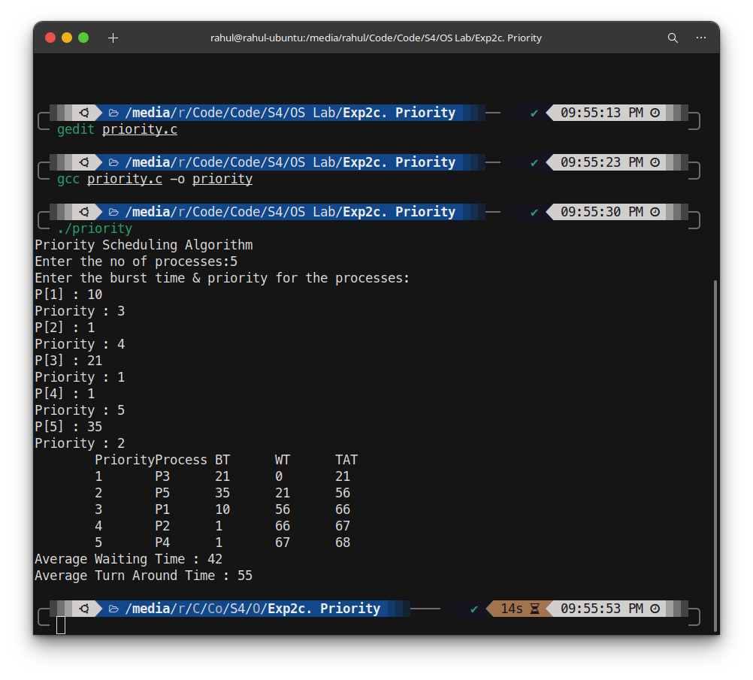
Output :

Experiment 2d: Round Robin Scheduling
Code :
#include <stdio.h>
int main()
{
int n,bt[10],i,temp[10],a=0,b=0,flag=0,at[10],sum,quantum;
float avgw=0,avgt=0;
printf("Round Robin Scheduling Algorithm\nEnter the no of process : ");
scanf("%d",&n);
int x=n;
for(i=0;i<n;i++){
printf("Enter the burst time P%d: ",i+1);
scanf("%d",&bt[i]);
temp[i]=bt[i];
at[i]=0;
}
printf("Enter the time quantum:");
scanf("%d",&quantum);
printf("\nprocess\tBT\tWT\tTAT\n");
i=0;
sum=0;
while(x!=0){
if(temp[i]<=quantum && temp[i]>0){
sum=sum+temp[i];
temp[i]=0;
flag=1;
}
else if(temp[i]>0){
temp[i]=temp[i]-quantum;
sum=sum+quantum;
}
if(temp[i]==0 && flag==1){
printf("P[%d]\t%d\t%d\t%d\n",i+1,bt[i],sum-bt[i],sum);
x--;
a=a+(sum-bt[i]);
b=b+sum;
flag=0;
}
if(i==n-1)
i=0;
else if(at[i]<=sum)
i++;
else
i=0;
}
printf("\n");
avgw=a/(n*1.0);
avgt=b/(n*1.0);
printf("\n");
printf("Average Turnaround time = %f\n",avgt);
printf("Average Waiting time =%f\n",avgw);
}

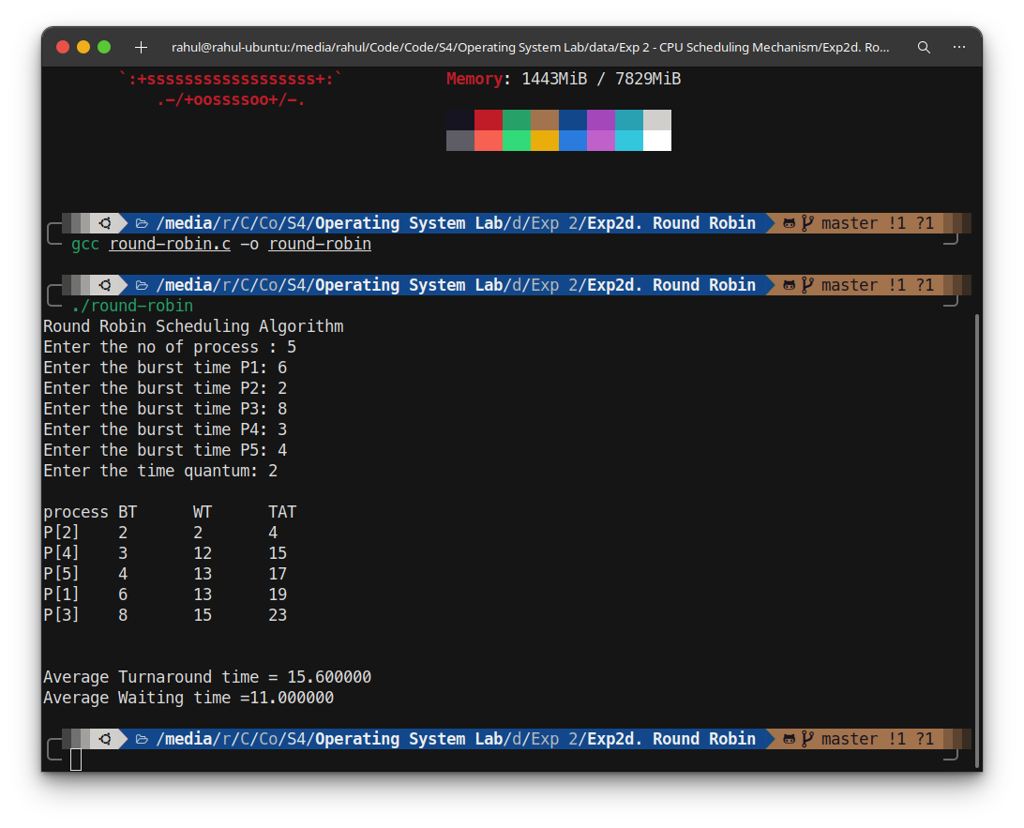
Output :

Experiment 3a: First-Fit Allocation
Code :
#include<stdio.h>

struct process {
int no;
int size;
int hole;
};
struct hole {
int no;
int size;
int bal;
};

void main() {
int a=0,b=0,temp1=0,temp2=0,flag=0;
printf("First Fit\n Enter No. of Process : ");
scanf("%d",&a);
struct process parr[a];
for (int i=0;i<a;i++) {
parr[i].no=i;
printf("Enter size of process P[%d] :",i);
scanf("%d",&parr[i].size);
parr[i].hole=(a*100);
}
printf("\n Enter No. of Hole : ");
scanf("%d",&b);
struct hole harr[b];
for (int i=0;i<b;i++) {
harr[i].no=i;
printf("Enter size of hole H[%d] :",i);
scanf("%d",&harr[i].size);
harr[i].bal=harr[i].size;
}
for ( int i=0;i<a;i++ ) {
flag=0;
for ( int j=0;j<b;j++) {
if (parr[i].size<=harr[j].bal) {
parr[i].hole=harr[j].no;
harr[j].bal=(harr[j].bal-parr[i].size);
flag=1;
break;
}
}
}

printf("\nFirst Fit Allocation\nProcess\t Size\tHole\n");
for (int i=0;i<a;i++) {
if (parr[i].hole!=(a*100)) {
printf("%d\t %d\t %d\n",parr[i].no,parr[i].size,parr[i].hole);
}
else {
printf("%d\t %d\t Not Allocated\n",parr[i].no,parr[i].size);
}
}
printf("\nHole\t Size\tBalance\n");
for (int i=0;i<b;i++) {
printf("%d\t %d\t %d\n",harr[i].no,harr[i].size,harr[i].bal);
}
}

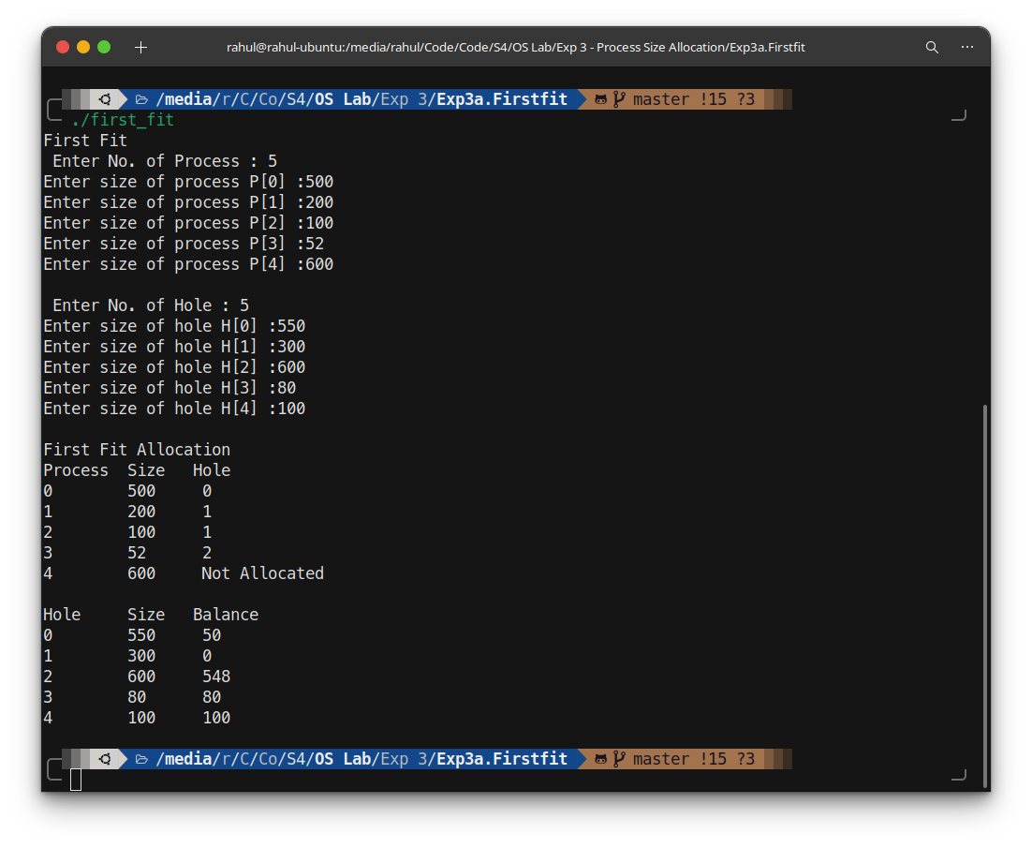
Output :

Experiment 3b: Best-Fit Allocation
Code :
#include<stdio.h>

struct process {
int no;
int size;
int hole;
};

struct hole {
int no;
int size;
int bal;
};

void main() {
int a=0,b=0,temp1=0,temp2=0,temp3=0,flag=0;
printf("Best Fit\n Enter No. of Process : ");
scanf("%d",&a);
struct process parr[a];
for (int i=0;i<a;i++) {
parr[i].no=i;
printf("Enter size of process P[%d] :",i);
scanf("%d",&parr[i].size);
parr[i].hole=(a*100);
}
printf("\n Enter No. of Hole : ");
scanf("%d",&b);
struct hole harr[b];
for (int i=0;i<b;i++) {
harr[i].no=i;
printf("Enter size of hole H[%d] :",i);
scanf("%d",&harr[i].size);
harr[i].bal=harr[i].size;
}

for (int i=0;i<b;i++) {
for (int j=0;j<b-i-1;j++) {
if (harr[j].size>harr[j+1].size) {
temp1=harr[j].no;
temp2=harr[j].size;
temp3=harr[j].bal;
harr[j].no=harr[j+1].no;
harr[j].size=harr[j+1].size;
harr[j].bal=harr[j+1].bal;
harr[j+1].no=temp1;
harr[j+1].size=temp2;
harr[j+1].bal=temp3;
}
}
}
for ( int i=0;i<a;i++ ) {
flag=0;
for ( int j=0;j<b;j++) {
if (parr[i].size<=harr[j].bal) {
parr[i].hole=harr[j].no;
harr[j].bal-=parr[i].size;
flag=1;
break;
}
}
}
for (int i=0;i<a;i++) {
for (int j=0;j<a-i-1;j++) {
if (parr[j].no>parr[j+1].no){
temp1=parr[j].no;
temp2=parr[j].size;
temp3=parr[j].hole;
parr[j].no=parr[j+1].no;
parr[j].size=parr[j+1].size;
parr[j].hole=parr[j+1].hole;
parr[j+1].no=temp1;
parr[j+1].size=temp2;
parr[j+1].hole=temp3;
}
}
}

for (int i=0;i<b;i++) {
for (int j=0;j<b-i-1;j++) {
if (harr[j].no>harr[j+1].no) {
temp1=harr[j].no;
temp2=harr[j].size;
temp3=harr[j].bal;
harr[j].no=harr[j+1].no;
harr[j].size=harr[j+1].size;
harr[j].bal=harr[j+1].bal;
harr[j+1].no=temp1;
harr[j+1].size=temp2;
harr[j+1].bal=temp3;
}
}
}
printf("\nBest Fit Allocation\nProcess\t Size\tHole\n");
for (int i=0;i<a;i++) {
if (parr[i].hole!=(a*100)) {
printf("%d\t %d\t %d\n",parr[i].no,parr[i].size,parr[i].hole);
}
else {
printf("%d\t %d\t Not Allocated\n",parr[i].no,parr[i].size);
}
}
printf("\nHole\t Size\tBalance\n");
for (int i=0;i<b;i++) {
printf("%d\t %d\t %d\n",harr[i].no,harr[i].size,harr[i].bal);
}
}

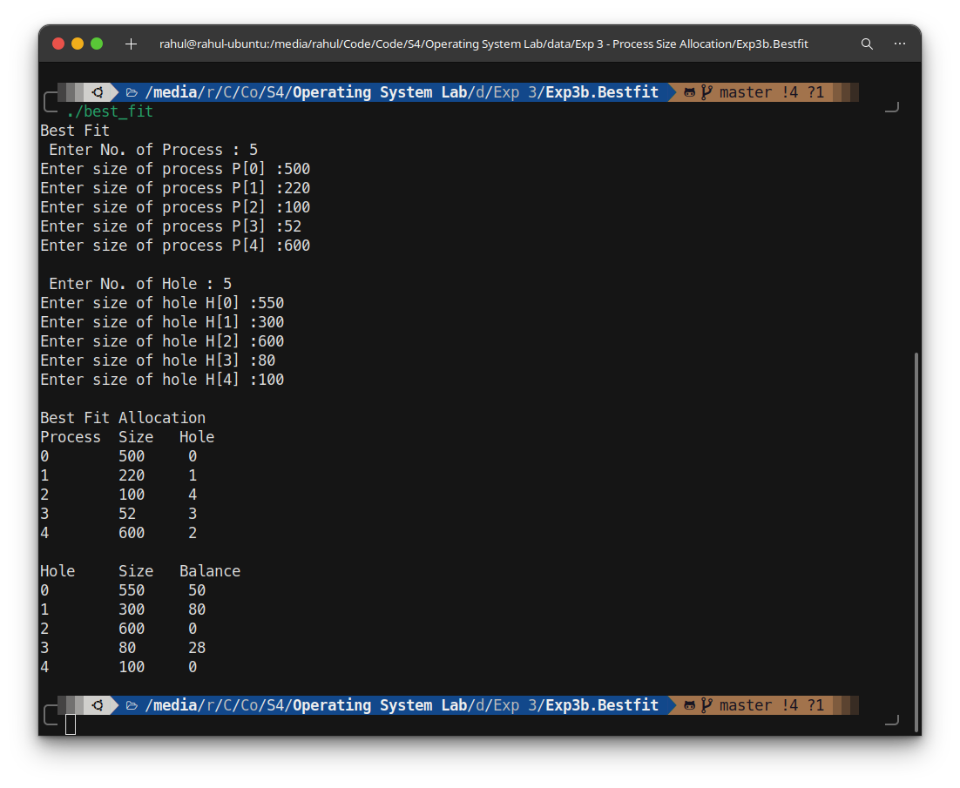
Output :

Experiment 3c: Worst-Fit Allocation
Code :
#include<stdio.h>

struct process {
int no;
int size;
int hole;
};

struct hole {
int no;
int size;
int balance;
};

void main() {
int a=0,b=0,temp1=0,temp2=0,temp3=0,flag=0;
printf("Worst Fit\n Enter No. of Process : ");
scanf("%d",&a);
struct process parr[a];
for (int i=0;i<a;i++) {
parr[i].no=i;
printf("Enter size of process P[%d] :",i);
scanf("%d",&parr[i].size);
parr[i].hole=(a*100);
}
printf("\n Enter No. of Hole : ");
scanf("%d",&b);
struct hole harr[b];
for (int i=0;i<b;i++) {
harr[i].no=i;
printf("Enter size of hole H[%d] :",i);
scanf("%d",&harr[i].size);
harr[i].balance=harr[i].size;
}
for ( int i=0;i<a;i++ ) {
flag=-1;
for ( int j=0;j<b;j++) {
if (harr[j].balance>parr[i].size) {
if (flag==-1)
flag=j;
else if (harr[j].balance > harr[flag].balance)
flag=j;
}
}
if (flag!=-1) {
parr[i].hole=flag;
harr[flag].balance-=parr[i].size;
}
}

printf("\nWorst Fit Allocation\nProcess\t Size\tHole\n");
for (int i=0;i<a;i++) {
if (parr[i].hole!=(a*100))
printf("%d\t %d\t %d\n",parr[i].no,parr[i].size,parr[i].hole);
else
printf("%d\t %d\t Not Allocated\n",parr[i].no,parr[i].size);
}
printf("\nHole\t Size\tBalance\n");
for (int i=0;i<b;i++) {
printf("%d\t %d\t %d\n",harr[i].no,harr[i].size,harr[i].balance);
}
}

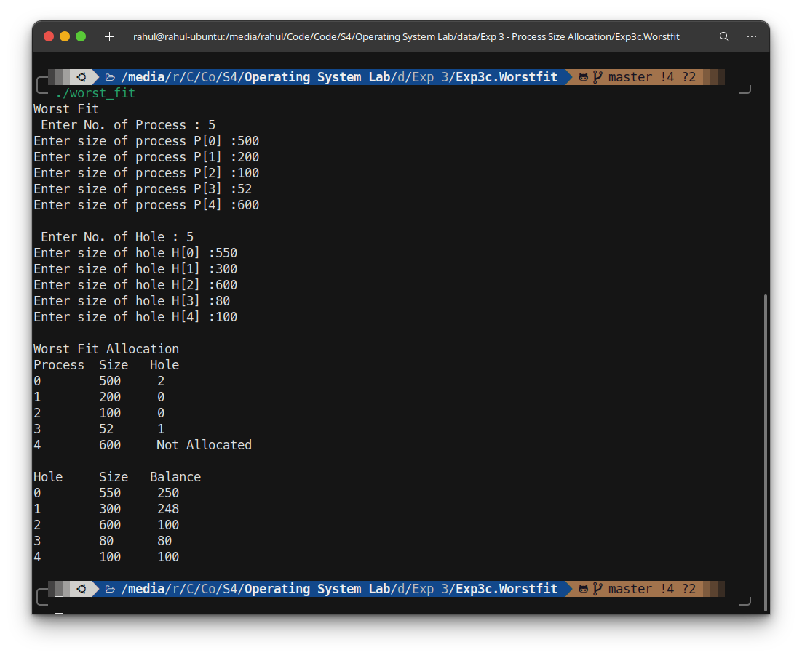
Output :

Experiment 4a: Display Hello World
Code :
echo Hello World

Experiment 4b: Check Odd Or Even
Code :
echo "Check Whether The Number Is Even Or Odd"
echo -n "Enter Number : " ; read number
if ((number%2==0))
then echo "Entered Number $number is even"
else echo "Entered Number $number is odd"
fi
Experiment 4c: Sum of first n number
Code :

echo "Display Sum Of First N Numbers "
echo -n "Enter The Number : " ; read number
sum=0
for ((i=1;i<=number;i++))
do
((sum=sum+i))
done
echo "The Sum Of First $number is $sum"

Experiment 4d: Factorial
Code :
echo "Find The Factorial Of Number"
echo -n "Enter The Number : " ; read number
if ((number==0))
then echo "Factorial Of $number is 1"
else
factorial=1
for ((i=1;i<=number;i++))
do
((factorial=factorial*i))
done
echo "Factorial Of $number is $factorial"
fi

Experiment 4e: Check For Amstrong Number
Code :
echo "Check For Amstrong Number"
echo -n "Enter Number : " ; read number
temp1=$number
temp2=$number
size=0
while ((temp1))
do
((size=size+1))
((temp1=temp1/10))
done
sum=0
while ((temp2))
do
((a=temp2%10))
b=1;
for ((i=0;i<size;i++))
do
((b=b*a))
done
((sum=sum+b))
((temp2=temp2/10))
done
amstrong=$sum
if ((amstrong==number))
then echo "The Number Is Amstrong"
else echo "The Number Is Not Amstrong"
fi

Experiment 4f: Find The Largest Number From N Numbers
Code :
echo "Find The Largest Number From N Numbers "
echo -n "The Number : " ; read number
temp1=$number
for ((i=0;i<number;i++))
do
echo -n "arr[$i] = "; read arr[$i]
done
for ((i=0;i<number;i++))
do
for ((j=0;j<number-i-1;j++))
do
if ((arr[j]>arr[j+1]))
then
temp=0
((temp=arr[j]))
((arr[j]=arr[j+1]))
((arr[j+1]=temp))
fi
done
done
((number=number-1))
echo "The Largest Of $temp1 is ${arr[$number]}"

Experiment 4g: Sum Of Digits Of A Number
Code :
echo "Sum Of Digits Of A Number"
echo -n "Enter the number : "; read number
temp1=$number
sum=0
while ((temp1))
do
((a=temp1%10))
((sum=sum+a))
((temp1=temp1/10))
done
echo "Sum of digits in $number is $sum"

Experiment 4h: Display Fibonacci Series
Code :
echo "Display Fibonacci Series"
echo -n "Enter the number to find the fibonacci : "; read number
a=0
b=1
sum=0
echo -n "Fibonacii Series : ";
for ((i=0;i<=number;i++))
do
if ((i==number))
then echo -n "$a "
else echo -n "$a, "
fi
((sum=a+b))
a=$b
b=$sum
done
echo

Experiment 4i: Swap 2 Number
Code :
echo "Swap 2 Number"
echo -n "Enter 1st Number : " ; read number1
echo -n "Enter 2nd Number : " ; read number2
echo "Read Number : $number1 & $number2"
temp=$number1
number1=$number2
number2=$temp
echo "After Swap Numbers : $number1 & $number2"

Experiment 4j: Sort Array
Code :
echo "Sort Array "
echo -n "The Size Of Array : " ; read number
temp1=$number
echo "Enter Array"
for ((i=0;i<number;i++))
do
echo -n "arr[$i] = " ; read arr[$i]
done
echo -n "Before Sorting : " ;
for ((i=0;i<number;i++))
do
echo -n "${arr[$i]} " ;
done
echo
for ((i=0;i<number;i++))
do
for ((j=0;j<number-i-1;j++))
do
if ((arr[j]>arr[j+1]))
then
temp=0
((temp=arr[j]))
((arr[j]=arr[j+1]))
((arr[j+1]=temp))
fi
done
done
echo -n "After Sorting : " ;
for ((i=0;i<number;i++))
do
echo -n "${arr[$i]} " ;
done
echo

Experiment 5a: First In First Out Page Replacement Algorithm
Code :
#include <stdio.h>
void main() {
int i,j,n,m,fnd,pg[100],fr[100],k=0,cnt=0,hit=0,miss=0;
printf("First In First Out Page Replacement Algorithm\nEnter The Number Of Pages : ");
scanf("%d",&n);
printf("Enter : ");
for(i=0;i<n;i++) {
scanf("%d",&pg[i]);
}
printf("Enter The Number Of Frame : ");
scanf("%d",&m);
for(i=0;i<m;i++) {
fr[i]=-1;
}
for(i=0;i<n;i++) {
fnd=0;
for(j=0;j<m;j++) {
if(fr[j]==pg[i]) {
fnd = 1;
}
}
if(fnd == 0) {
fr[k] = pg[i];
k = (k+1)%m;
cnt++;
}
if(fnd==1)
hit++:
else
miss++;
}
printf("\nTotal No. of Page Fault : %d",cnt);
printf("\nTotal No. of Hit : %d",hit);
printf("\nTotal No. of Miss : %d",miss);
printf("\nLast Frame : ");
for (int i=0;i<m;i++) {
printf("%d ",fr[i]);
}
printf("\n");
}

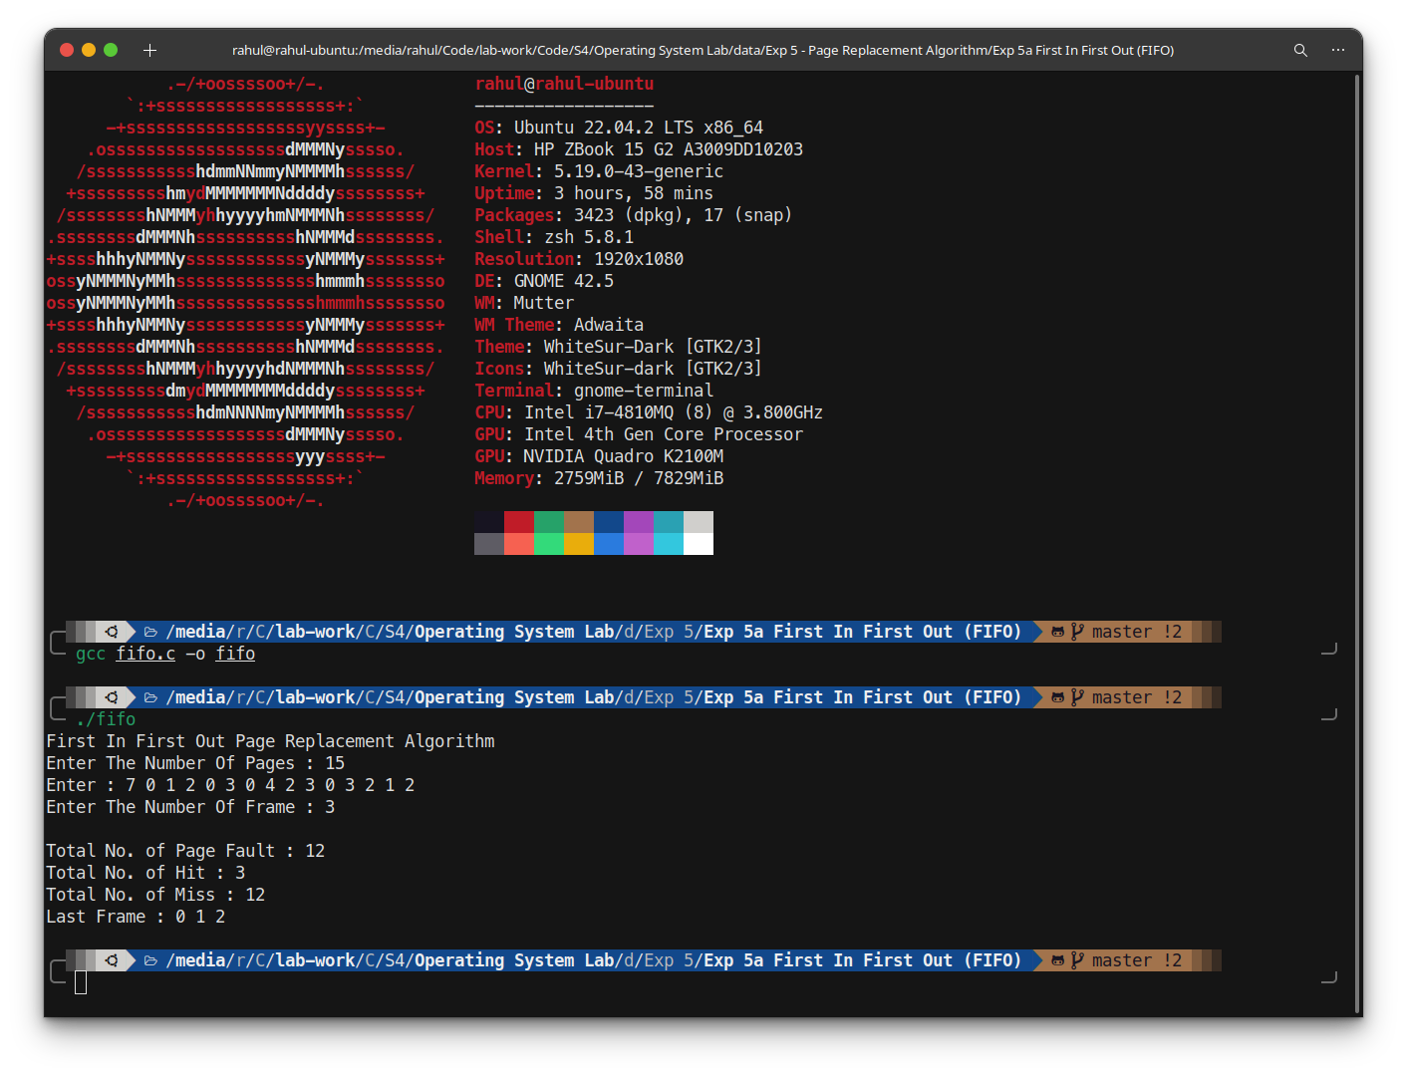
Output :

Experiment 5b: Least Recently Used Page Replacement Algorithm
Code :
#include <stdio.h>
void main() {
int pg, frm, pgno[100], frno[100], i, j, k, l, flag, pgfault = 0, pghit = 0;
printf("Least Recently Used Page Replacement Algorithm\nEnter No. of pages : ");
scanf("%d", &pg);
printf("Enter : ");
for(i = 0; i < pg; i++) {
scanf("%d", &pgno[i]);
}
printf("Enter No. of frames: ");
scanf("%d", &frm);
for(i = 0; i < frm; i++) {
frno[i] = -1;
}
printf("\nPage\t");
for(k = 1; k <= frm; k++) {
printf("Frame%d\t", k);
}
printf("\n");
for(i = 0; i < pg; i++) {
flag = 0;
for(j = 0; j < frm; j++) {
if(frno[j] == pgno[i]) {
pghit++;
flag = 1;
printf("%d\t", pgno[i]);
for(k = 0; k < frm; k++) {
printf("%d\t", frno[k]);
}
printf("\n");
break;
}
}
if(flag==0) {
int min=999, index;
for(j=0; j<frm; j++) {
int found = 0;
for(k=i-1; k>=0; k--) {
if(frno[j] == pgno[k]) {
found = 1;
if(k < min) {
min = k;
index=j;
}
break;
}
}
if(!found) {
index=j;
break;
}

}
frno[index] = pgno[i];
pgfault++;
printf("%d\t", pgno[i]);
for(k = 0; k < frm; k++)
{
printf("%d\t", frno[k]);
}
printf("\n");
}
}
printf("\nTotal Page Faults : %d\n", pgfault);
printf("Total Hits : %d\n", pghit);
}


Output :

Experiment 5c: Optimal Page Replacement Algorithm
Code :
#include<stdio.h>
int main()
{
int no_of_frames, no_of_pages, frames[10], pages[30], temp[10], flag1, flag2, flag3, i, j, k, pos, max, faults = 0,a=0;
printf("Optimal Page Replacement Algorithm\nEnter No. of pages: ");
scanf("%d", &no_of_pages);
printf("Enter : ");
for(i = 0; i < no_of_pages; ++i) {
scanf("%d", &pages[i]);
}
printf("Enter No. of frames: ");
scanf("%d", &no_of_frames);
for(i = 0; i < no_of_frames; ++i+) {
frames[i] = -1;
}
printf("\nPage");
for(i=0;i<no_of_frames;i++) {
printf("\tFrame %d",i);
}
for(i = 0; i < no_of_pages; ++i) {
flag1 = flag2 = 0;
for(j = 0; j < no_of_frames; ++j) {
if(frames[j] == pages[i]) {
flag1 = flag2 = 1;
break;
}
}
if(flag1 == 0) {
for(j = 0; j < no_of_frames; ++j) {
if(frames[j] == -1) {
faults++;
frames[j] = pages[i];
flag2 = 1;
break;
}
}
}
if(flag2 == 0) {
flag3 =0;
for(j = 0; j < no_of_frames; ++j) {
temp[j] = -1;
for(k = i + 1; k < no_of_pages; ++k) {
if(frames[j] == pages[k]) {
temp[j] = k;
break;
}
}
}

for(j = 0; j < no_of_frames; ++j) {
if(temp[j] == -1) {
pos = j;
flag3 = 1;
break;
}
}
if(flag3 ==0)
{
max = temp[0];
pos = 0;
for(j = 1; j < no_of_frames; ++j)
{
if(temp[j] > max)
{
max = temp[j];
pos = j;
}
}
}
frames[pos] = pages[i];
faults++;
}
printf("\n");
printf("%d\t",pages[a]);
a++;
for(j = 0; j < no_of_frames; ++j)
{
printf("%d\t", frames[j]);
}
}
printf("\n\nTotal Page Faults : %d", faults);
printf("\nTotal Page Hits : %d\n", no_of_pages-faults);
return 0;
}

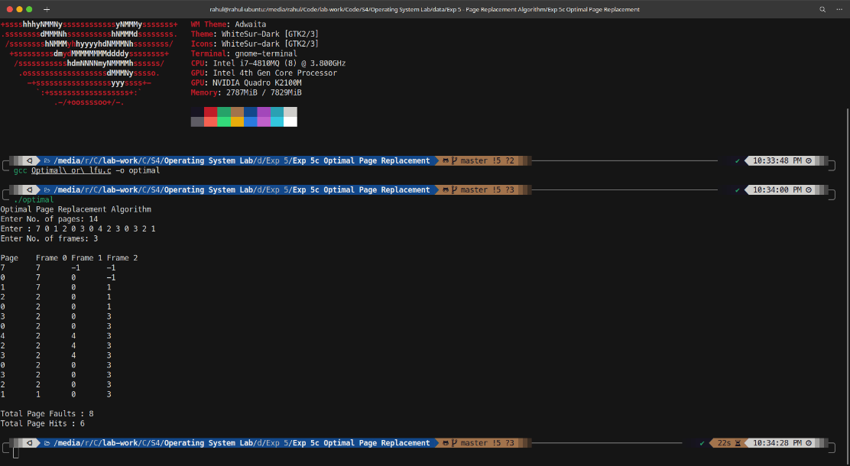
Output :

Experiment 6a: First Come First Serve
Code :
#include <stdio.h>
#include <math.h>
int request_arr[20], request, distance, head, seek = 0, i;

int main() {
printf("Disk Scheduling\nFirst Come First Serve\nEnter the number of requests: ");
scanf("%d", &request);
printf("Enter the requests: ");
for (i = 0; i < request; i++)
scanf("%d", &request_arr[i]);
printf("Enter the head position: ");
scanf("%d", &head);
printf("Path: %d->", head);
for (i = 0; i < request; i++) {
printf("%d", request_arr[i]);
if (i + 1 != request) {
printf("->");
}
}
for (i = 0; i < request; i++) {
distance = fabs(head - request_arr[i]);
seek += distance;
head = request_arr[i];
}
printf("\nTotal seek distance: %d\n", seek);
return 0;
}

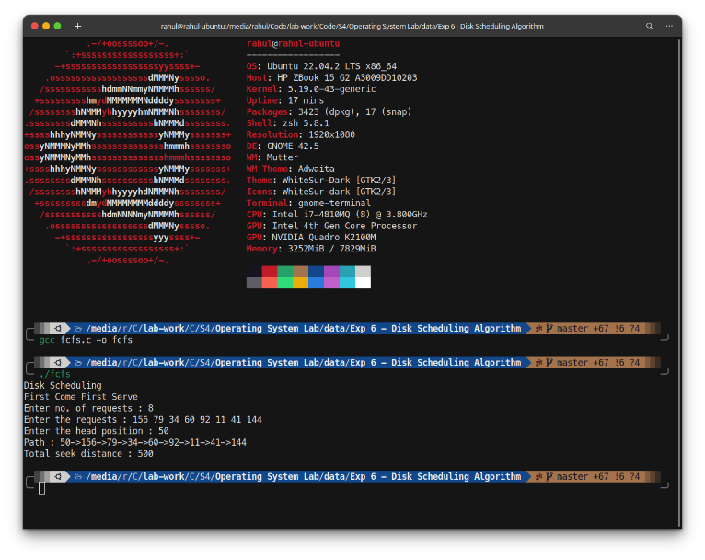
Output :

Experiment 6b: SCAN
Code :
#include<stdio.h>
int request_arr[20], request, head, size, seek = 0, i, j, direction;

int main() {
printf("Disk Scheduling\nSCAN\nEnter the number of requests : ");
scanf("%d", &request);
printf("Enter the requests : ");
for (i = 0; i < request; i++)
scanf("%d", &request_arr[i]);
printf("Enter the initial head position : ");
scanf("%d", &head);
printf("Total disk size : ");
scanf("%d", &size);
printf("Enter the head movement direction\n0-From the beginning\n1-From the end track\nChoice : ");
scanf("%d", &direction);

// Sort
for (i = 0; i < request - 1; i++) {
for (j = 0; j < request - i - 1; j++) {
int temp;
if (request_arr[j] > request_arr[j + 1]) {
temp = request_arr[j];
request_arr[j] = request_arr[j + 1];
request_arr[j + 1] = temp;
}
}
}
printf("Path : %d->", head);

// Case 1
if (direction == 0) {
int start = 0;
for (i = 0; i < request; i++) {
if (request_arr[i] < head)
start = i;
else
break;
}
for (i = start; i >= 0; i--) {
seek += (head - request_arr[i]);
head = request_arr[i];
printf("%d->", request_arr[i]);
}
seek += head;
printf("0->");
head = 0;

// Greater than head
for (i = start + 1; i < request - 1; i++) {
seek += (request_arr[i] - head);
head = request_arr[i];
printf("%d->", request_arr[i]);
}

seek += request_arr[i] - head;
printf("%d", request_arr[i]);
}

// Case 2
else {
int start = 0;
for (i = 0; i < request; i++) {
if (request_arr[i] < head)
start = i;
else
break;
}

for (i = start + 1; i < request; i++) {
seek += (request_arr[i] - head);
head = request_arr[i];
printf("%d->", request_arr[i]);
}

printf("%d->", size - 1);
seek += ((size - 1) - head);
head = size - 1;

for (i = start; i > 0; i--) {
seek += (head - request_arr[i]);
head = request_arr[i];
printf("%d->", request_arr[i]);
}

seek += (head - request_arr[i]);
printf("%d\n", request_arr[i]);
}

printf("\nTotal seek distance is : %d\n", seek);
return 0;
}

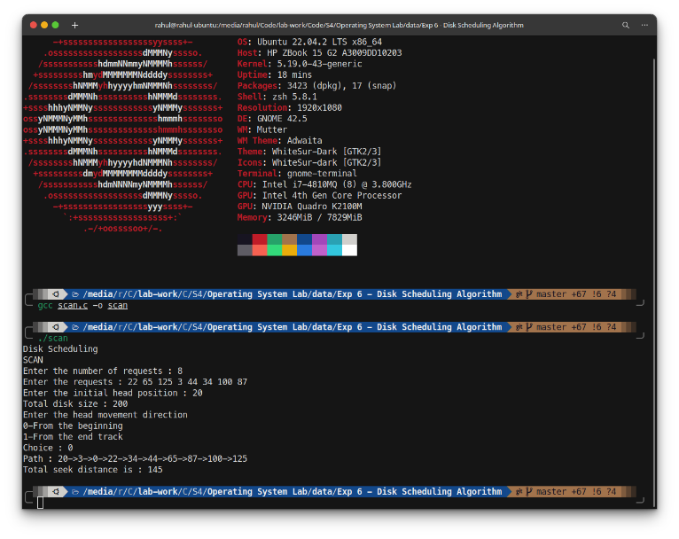
Output :

Experiment 6c: CSCAN
Code :
#include <stdio.h>
int main() {
int request_arr[20], request, head, size, direction, seek = 0, i, j;
printf("Disk Scheduling\nCircular SCAN\nEnter the number of requests: ");
scanf("%d", &request);
printf("Enter the requests: ");
for (i = 0; i < request; i++)
scanf("%d", &request_arr[i]);
printf("Enter the initial head position: ");
scanf("%d", &head);
printf("Total disk size: ");
scanf("%d", &size);
printf("Enter the head movement direction\n0-towards end\n1-Towards beginning\nChoice: ");
scanf("%d", &direction);

// Sort
for (i = 0; i < request - 1; i++) {
for (j = 0; j < request - i - 1; j++) {
int temp;
if (request_arr[j] > request_arr[j + 1]) {
temp = request_arr[j];
request_arr[j] = request_arr[j + 1];
request_arr[j + 1] = temp;
}
}
}
printf("Path: %d->", head);

// Greater than head
if (direction == 0) {
int start = 0;
for (i = 0; i < request; i++) {
if (request_arr[i] < head)
start = i;
else
break;
}
for (i = start + 1; i < request; i++) {
seek += (request_arr[i] - head);
head = request_arr[i];
printf("%d->", request_arr[i]);
}
seek += ((size - 1) - head);
printf("%d->", size - 1);
seek += (size - 1);
printf("0->");
head = 0;

// Less than head
for (i = 0; i < start; i++) {
seek += (request_arr[i] - head);
head = request_arr[i];
printf("%d->", request_arr[i]);
}

seek += request_arr[i] - head;
printf("%d", request_arr[i]);
}

// Case 2
else {
int start = 0;
for (i = 0; i < request; i++) {
if (request_arr[i] < head)
start = i;
else
break;
}
for (i = start; i >= 0; i--) {
seek += (head - request_arr[i]);
head = request_arr[i];
printf("%d->", request_arr[i]);
}
seek += head;
printf("0->");
seek += (size - 1);
head = size - 1;
printf("%d->", head);

// Greater
for (i = request - 1; i > start + 1; i--) {
seek += (head - request_arr[i]);
head = request_arr[i];
printf("%d->", request_arr[i]);
}
seek += request_arr[i] - head;
printf("%d", request_arr[i]);
}
printf("\nTotal seek distance is: %d\n", seek);
return 0;
}

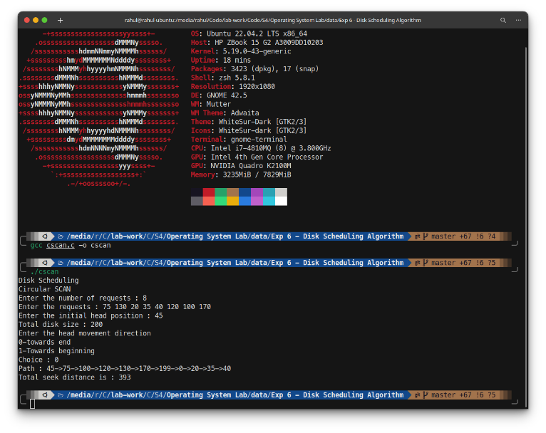
Output :

Experiment 7: Banker’s Algorithm
Code :
#include<stdio.h>
int cols, rows, i, j, k, l, count = 0, claim[10], alloc[10][10], max_claim[10][10], avail[1][10], sum_allo[10], done[10], need_tab[10][10];
int main() {
printf("Banker's Algorithm\nEnter the number of processes: ");
scanf("%d", &rows);
printf("Enter the number of resources: ");
scanf("%d", &cols);
printf("Enter the Claim Vector: ");
for (i = 0; i < cols; i++)
scanf("%d", &claim[i]);
printf("Enter the Allocated Table:\n");

// Resource table
for (i = 0; i < rows; i++) {
for (j = 0; j < cols; j++) {
scanf("%d", &alloc[i][j]);
sum_allo[j] = 0;
}
}
printf("Enter the Claim Table:\n");

// Claim table
for (i = 0; i < rows; i++) {
for (j = 0; j < cols; j++)
scanf("%d", &max_claim[i][j]);
}

for (i = 0; i < rows; i++)
done[i] = -1;

for (i = 0; i < rows; i++) {
for (j = 0; j < cols; j++)
need_tab[i][j] = max_claim[i][j] - alloc[i][j];
}
printf("The Need Table\n");
for (i = 0; i < rows; i++) {
for (j = 0; j < cols; j++)
printf("%d\t", need_tab[i][j]);
printf("\n");
}
printf("\n");

// Print claim
printf("The claim vector is: ");
for (i = 0; i < cols; i++)
printf("%d ", claim[i]);
printf("\n\n");

// Print resource table
printf("Allocation Table\n");
for (i = 0; i < rows; i++) {
for (j = 0; j < cols; j++)
printf("%d\t", alloc[i][j]);
printf("\n");
}

// Print claim table
printf("\nMax Table\n");
for (i = 0; i < rows; i++) {
for (j = 0; j < cols; j++)
printf("%d\t", max_claim[i][j]);
printf("\n");
}

// Sum of allocated resources
printf("\nAllocated Resources: ");
for (j = 0; j < cols; j++) {
sum_allo[j] = 0;
for (i = 0; i < rows; i++) {
sum_allo[j] += alloc[i][j];
}
printf("%d\t", sum_allo[j]);
}
printf("\n");

// Print available resources
printf("\nAvailable Resources: ");
for (i = 0; i < cols; i++) {
avail[0][i] = claim[i] - sum_allo[i];
printf("%d\t", avail[0][i]);
}
int executed = 0, array[10];
while (executed < rows) {
for (i = 0; i < rows; i++) {
count = 0;
if (done[i] != 1) {
for (j = 0; j < cols; j++) {
if (need_tab[i][j] <= avail[0][j])
count++;
else
break;
}

if (count == cols) {
done[i] = 1;
array[executed] = i;
executed += 1;
printf("\tProcess P%d is executing (safe state)\nAvailable vector: ", i);
for (k = 0, l = 0; k < cols && l < cols; k++, l++)
printf("%d\t", avail[0][k] += alloc[i][l]); // Available vector
}
}
}
}
printf("\nSafe Sequence: ");
for (i = 0; i < rows; i++) {
printf("P%d", array[i]);
if ((i + 1) != rows) {
printf("->");
}
}
printf("\n");
return 0;
}

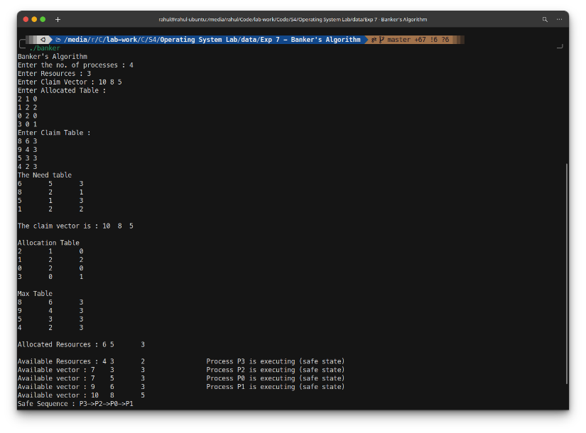
Output :

Experiment 8a: Continous Allocation
Code :
#include<stdio.h>

void main() {
int files,choice1,choice2,q=1;
printf("Contiguous File Allocation\nEnter No. of Files : ");
scanf("%d",&files);
int start[files],length[files];
for (int i=1;i<=files;i++) {
printf("Enter File %d Details : \n\tEnter starting block : ",i);
scanf("%d",&start[i]);
printf("\tEnter Length : ");
scanf("%d",&length[i]);
}
printf("\nFile Name\tStart Block\tLength\n");
for (int i=1;i<=files;i++) {
printf("%d\t\t%d\t\t%d\n",i,start[i],length[i]);
}
do {
printf("Menu\n\tPress 1 Sequential File Allocation\n\tPress 2 Exit\nChoice : ");
scanf("%d",&choice1);
switch(choice1) {
case 1:
printf("\nEnter File Name : ");
scanf("%d",&choice2);
printf("\n File Name is %d",choice2);
printf("\n Length is : %d",length[choice2]);
printf("\n Blocks Occupied : ");
int a=start[choice2];
int b=length[choice2];
for (int i=0;i<b;i++) {
printf("%d",a);
a++;
if (i<(b-1)){
printf("->");
}
}
printf("\n");
break;
case 2:
q=0;
break;
}
} while(q==1);
}

Output :
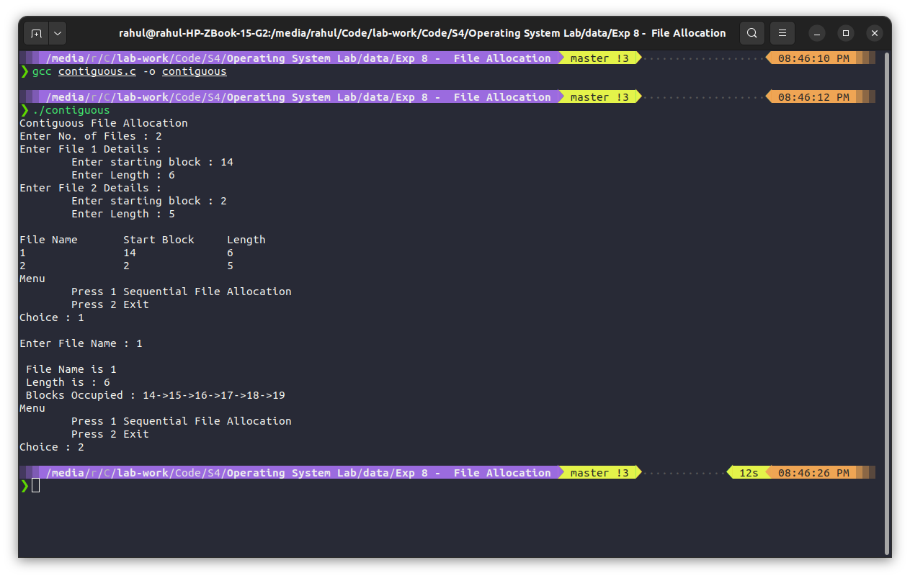

Experiment 8b: Linked Allocation
Code :
#include<stdio.h>
#include<stdlib.h>

int n, len[20], start[20];
struct Block{
int data;
struct Block *next;
};
struct Block * head[20];

void showAlloc() {
int fn;
printf("\nEnter file name (0 = exit) : ");
scanf("%d", &fn);
struct Block *temp;
if(fn != 0){
temp = head[fn-1];
printf("\nFile name is: %d", fn);
printf("\nLength is: %d", len[fn-1]);
printf("\nBlocks occupied : ");
int length=len[fn-1];
for(int i=0; i<length; i++){
printf("%d", temp->data);
temp = temp->next;
if(i<(length-1)) {
printf("->");
}
}
while(fn != 0){
showAlloc();
}
} else{
exit(0);
}
}

void main() {
printf("Linked List File Allocation\nEnter the no of Files : ");
scanf("%d", &n);
for(int i=0; i<n; i++){
int item;
struct Block *new;
struct Block *temp;
head[i] = NULL;
new = (struct Block *)malloc(sizeof(struct Block));
printf("Enter the length file %d : ", i+1);
scanf("%d", &len[i]);
printf("Enter the starting block of file %d : ", i+1);
scanf("%d", &item);
new->data = item;
new->next = NULL;
head[i] = new;
printf("Enter the blocks : ");
for(int j=0; j<len[i]-1; j++){
scanf("%d", &item);
struct Block *new;
struct Block *temp;
new = (struct Block *)malloc(sizeof(struct Block));
new->data = item;
new->next = NULL;
temp = head[i];
while(temp->next != NULL){
temp = temp->next;
}
temp->next = new;
}
}
printf("\nFile Name\t\tStart Block\t\tLength\t\tBlock");
for(int i=0; i<n; i++){
struct Block *temp;
temp = head[i];
printf("\n%d\t\t\t %d\t\t\t %d\t\t", i+1, temp->data, len[i]);
while(temp->next != NULL){
printf("%d->", temp->data);
temp = temp->next;
}
printf("%d", temp->data);
}
showAlloc();
}

Output :
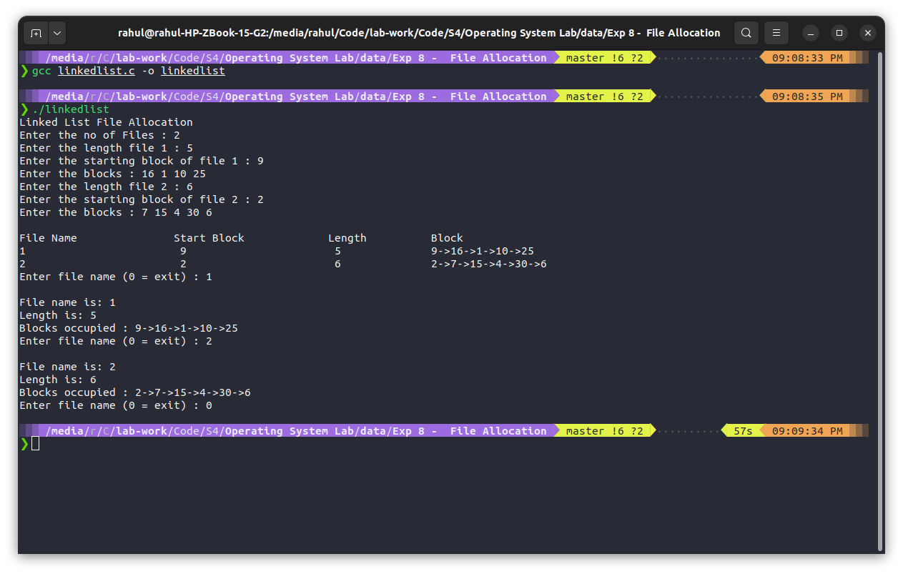

Experiment 8c: Indexed Allocation
Code :
#include<stdio.h>
#include<stdlib.h>
int n, len[20], Idx[20];
struct Block{
int data[20];
}blk[20];

void showAlloc(){
int fn;
printf("\nEnter file name (0 = exit) : ");
scanf("%d", &fn);
if(fn!=0) {
printf("\nFile name is : %d", fn);
printf("\nLength is : %d", len[fn-1]);
printf("\nIndex is : %d", Idx[fn-1]);
printf("\nBlocks occupied : ");
for(int i=0; i<len[fn-1]; i++)
printf("\t %d", blk[Idx[fn-1]].data[i]);
while(fn!=0){
showAlloc();
}
} else {
exit(0);
}
}

void main() {
printf("Indexd File Allocation\nEnter no. of Files: ");
scanf("%d", &n);
for(int i=0; i<n; i++){
int item;
printf("Enter index of file %d: ", i+1);
scanf("%d", &Idx[i]);
printf("Enter Length of file %d: ", i+1);
scanf("%d", &len[i]);
printf("Enter the blocks: ");
for(int j=0; j<len[i]; j++){
scanf("%d", &blk[Idx[i]].data[j]);
}
}
printf("\nFile Name\t\t Length\t\t Index");
for(int i=0; i<n; i++)
printf("\n%d\t\t\t %d\t\t\t%d",i+1, len[i], Idx[i]);
showAlloc();
}

Output :
